Практическое занятие

Тема: Защита растений: сорняки. (2 часа)

Цель занятия: переводить (со словарем) иностранные тексты профессиональной направленности; самостоятельно совершенствовать устную и письменную речь, пополнять словарный запас. овладеть лексическим и грамматическим минимумом, необходимым для чтения и перевода (со словарем) иностранных текстов профессиональной направленности;
Сформированные компетенции: ОК 09
ОК 09. Пользоваться профессиональной документацией на государственном и иностранном языках
Требования к выполнению работы:
- Изучить лексический материал по теме.
- Оформить лексический материал в тетради.
- Прочитать текст и выполнить упражнения
- Выполнить индивидуальное задание в тетради.

1. Изучить лексический материал по теме
weeds, weeds control, weed mapping, annual, biennial, perennial, life cycle, tap roots, cover crops, mulch

2. Оформить лексический материал в тетради
2.1. Match the words with their definitions:
- annual  - biennial  - perennial  - life cycle  - tap roots  - cover crops  - mulch | - a crop grown to protect soil from erosion  - the series of change that a living thing goes through from the beginning of its life until death  - relating to a period of one year  - a layer of material applied to the surface of soil  - happening once every two years  - lasting a very long time  - a thick main root in some plants
3. Прочитать текст и выполнить упражнения

Text: Weeds

So what are weeds and where do weeds grow? By definition, a weed is known as “a plant in the wrong place.” For the most part, these plants are known more for their undesirable qualities rather than for their good ones, should there be any. Weeds are competitive, fighting your garden plants or lawn grass for water, light, nutrients, and space.
There are generally three types of common weed plants in regards to their growing characteristics. These include:
- Annual types – Annual weeds germinate and spread by seed, having a lifespan of one year.
- Biennial types – Biennial weeds complete their life cycle in two years, germinating and forming rosettes their first year and producing flowers and seeds their second year. Examples: bull thistle and garlic mustard.
- Perennial types – Perennial weeds return every year and produce long tap roots in addition to seeds. These weeds, which include dandelions, plantain, and purple loosestrife, are the most difficult to control.

There are a number of weed control methods, depending on the weed and the gardener:
- Cultural weed control – close planting in the garden can reduce weed growth by eliminating open space. Cover crops are good for this as well. Adding mulch will prevent light from getting to weed seeds and prevents growth.
- Mechanical weed control – can be accomplished through hand pulling, hoeing, digging, or mowing. While these methods are effective, they can be time consuming.
- Chemical weed control – chemical control is sometimes necessary, and used normally a last resort. There are numerous herbicides available to help eliminate common weed plants.
- Natural weed control – some weeds can be quite attractive in the garden, so why not to allow them to stay. This more natural weed control method results in a lush native environment when given their own designated spot.

Of course, which weed goes and which weed stays depends on the individual gardener, though a little bit of weed info and control methods makes this decision easier.

1. Discuss the mentioned weed control methods and decide which one is the most effective.
2. Name the most damaging weeds spread in our country.

3. Mark the statements true or false:
- A weed is an undesirable plant.
- There are annual and perennial weed types.
- Cultural weed control involves using mulching and limiting space.
- Chemical weed control should be used in extreme case when nothing else helps.
- Mechanical weed control isn’t effective as it is time consuming.
- Natural weed control method involves using natural pesticides to fight weeds.

4. Выполнить индивидуальное задание в тетради.

Weed mapping

1. Make a list of weeds you want to map, generally those you want to control or are concerned about.
2. Get a map of your property. You may need several copies depending on the number of
species you want to map.
3. Mark the extent of all priority weed infestations on your map and record:
• date
• common name
• scientific name
• cover (Trace <1%, Light 1-10%, Medium 11-50%, Dense >50%)
• comments
• control method (if controlling weeds at the same time).
4. Make a map and write a short summary:
1. Set a goal (e.g. to remove all blackberry or reduce blackberry to less than 5% cover)
2. Choose appropriate control methods
3. Plan the actions you need to take each year to achieve your goal
4. Check that you have the suitable licenses, equipment and herbicides to control the weeds.

Example of weed mapping

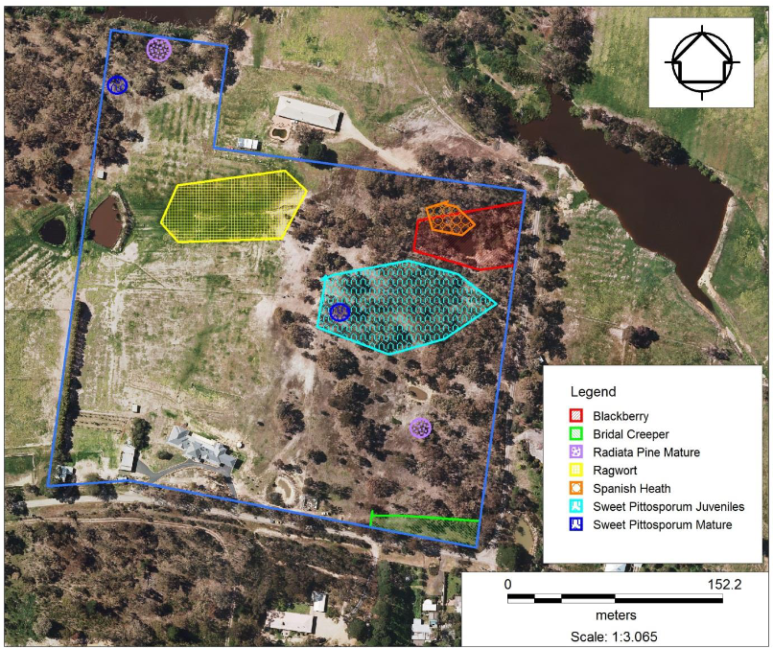

Литература:

Основная: O₁: Белоусова А.Р., Мельчина О.П. Английский язык для студентов сельскохозяйственных вузов: Учебное пособие. 5-е изд., - СПб.: Издательство «Лань», 2016. - 352 с.: ил. - (Учебники для вузов Специальная литература) (электронное издание)
Дополнительная: О₂: What Is A Weed: Weed Info And Control Methods In Gardens https://www.gardeningknowhow.com/plant-problems/weeds/what-is-a-weed.htm

