Тренировочные упражнения по теме «Профессии»
Form: 5
Topic: People. Past Simple
Language Focus
Aims:
- to revise and consolidate vocabulary and structures learnt in previous lessons;
- to talk about occupations;
- to identify regular and irregular verbs;
- to distinguish between present and past events.
Vocabulary: occupations, regular and irregular verbs.
Structures: A baker bakes…, a baker baked... A teacher teaches…, a teacher taught...
He is a doctor. She is an engineer.
Materials: flashcards of occupations, cutouts of regular and irregular verbs (present and past forms).
Outcomes: at the end of the lesson, the students will be able to point and name the vocabulary and structures of the lesson, to identify regular and irregular verbs, to distinguish between present and past events, to make up sentences using Past Simple.
Objectives: to introduce and practise the vocabulary and structures of the lesson, to develop students` listening, speaking, reading and writing skills.
Activity 1. Listen to the riddles about occupations and guess.

- I wear a uniform.
I often have a gun.
I conduct of traffic.
I catch thieves.
Answer: a policeman

- I work in the sky.
I’m often a woman.
I serve food and drinks.
I’m usually good-looking.
Answer: a stewardess

- I use markers or chalk.
I work in a school.
I have students.
I give homework.
Answer: a teacher

- I work in an office.
I make phone calls.
I send emails.
I make appointments.
Answer: a secretary
- I work with scissors.
I work in a salon.
I wash, dry and brush.
I cut hair.
Answer: a hairdresser
- I wear a white hat.
I feed people.
I work in a kitchen.
I cook.
Answer: a cook
- I wear a uniform.
I walk or cycle a lot.
I don’t like dogs.
I deliver mail.
Answer: a postman
- I work at or near home.
I drive a tractor.
I grow vegetables.
I have animals in the field.
Answer: a farmer
- I wear a uniform.
I work in shifts.
People in trouble call me.
I put out fires.
Answer: a firefighter
- For what person do all men take off their hats?
Answer: a barber

Activity 2. Choose the correct words from the list below and write them under the correct picture.
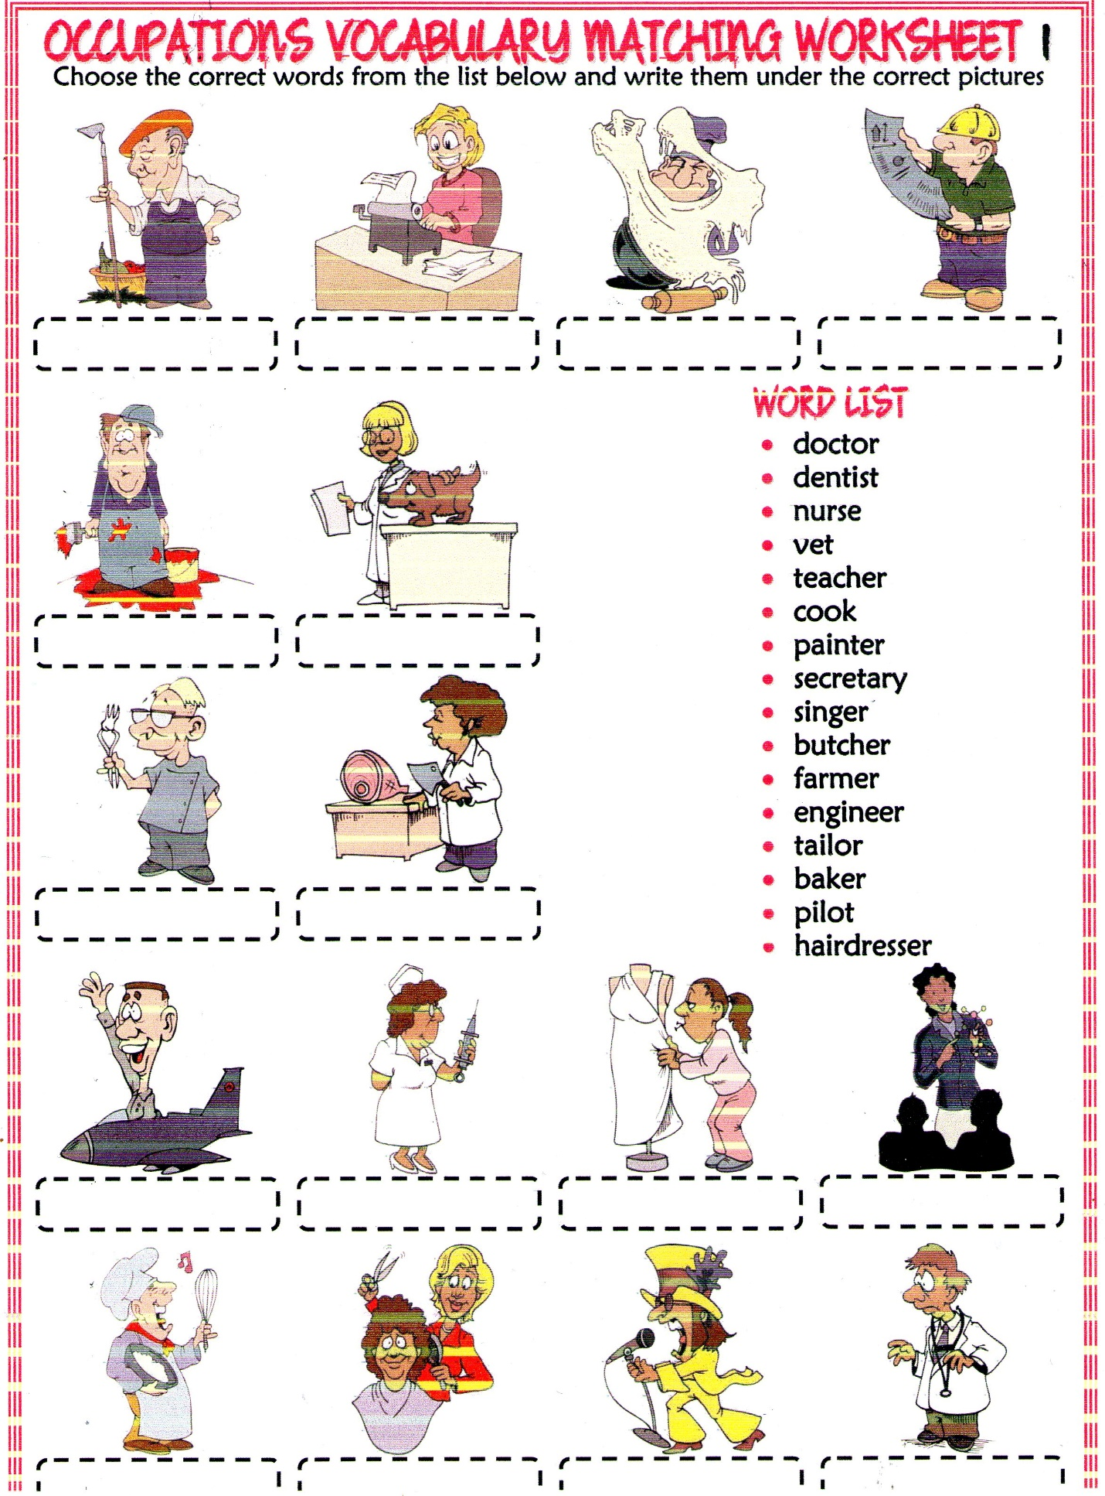

Activity 3. Identify regular or irregular verbs. Choose the correct past forms.

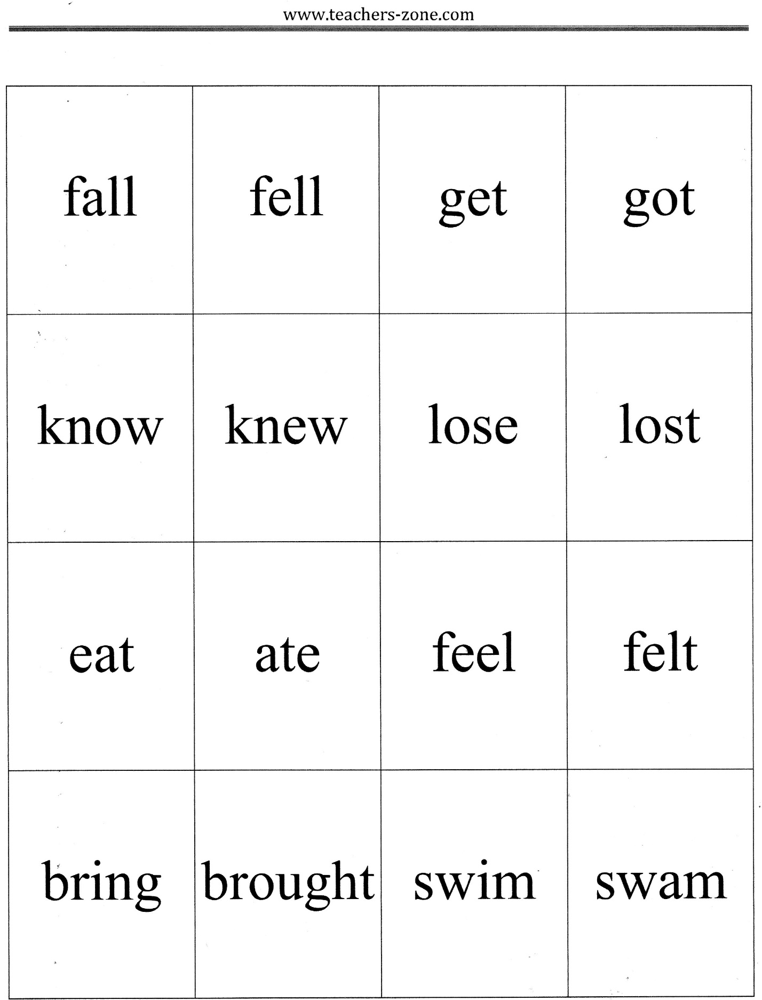
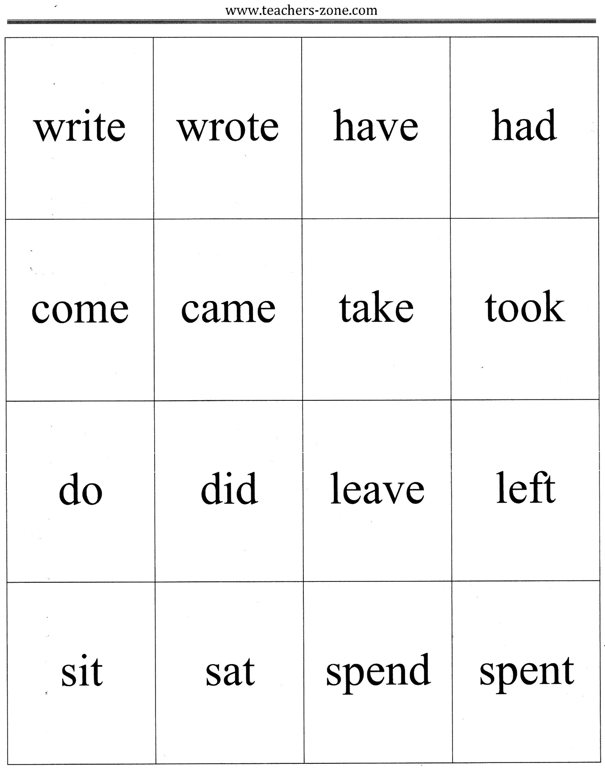
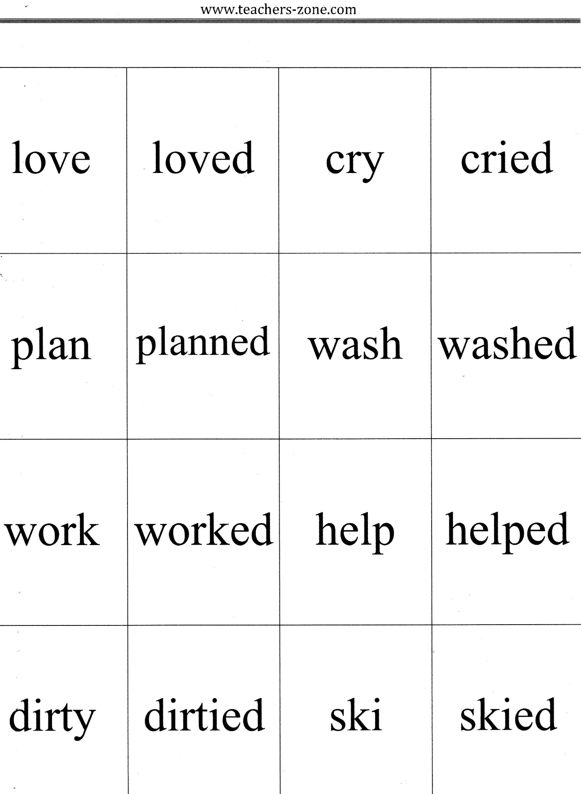
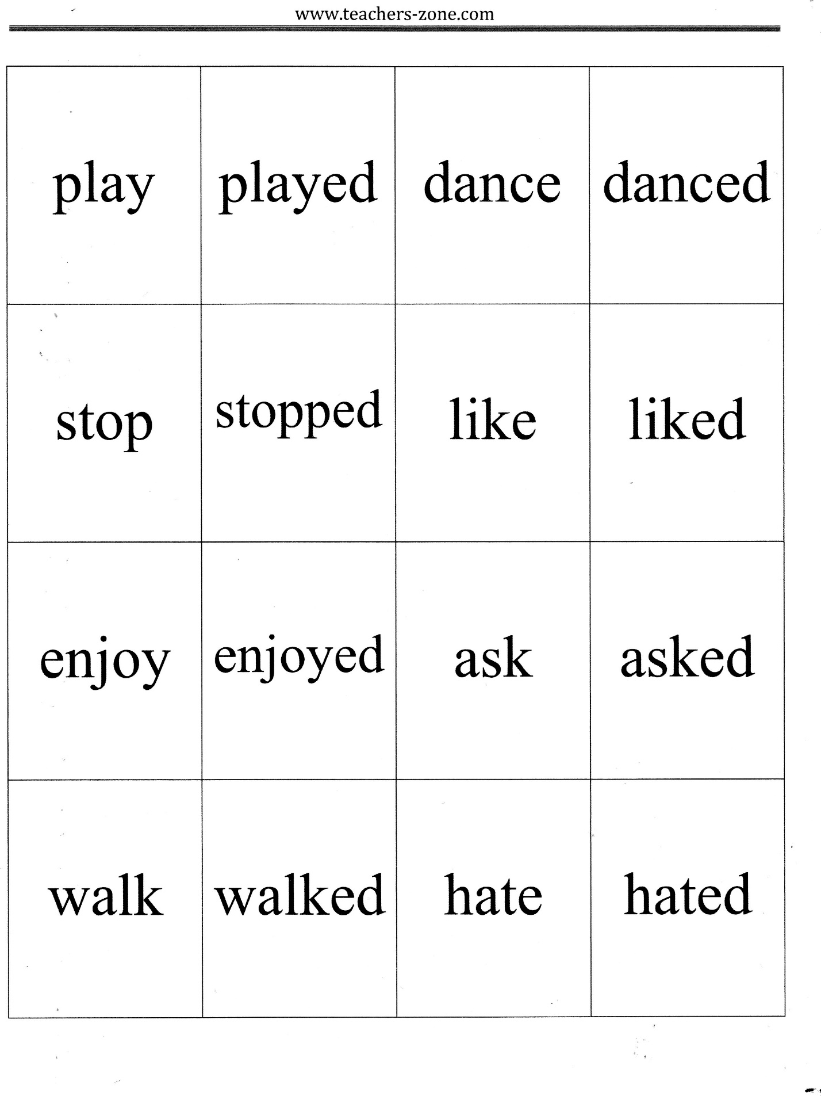

Activity 4. Read and match.
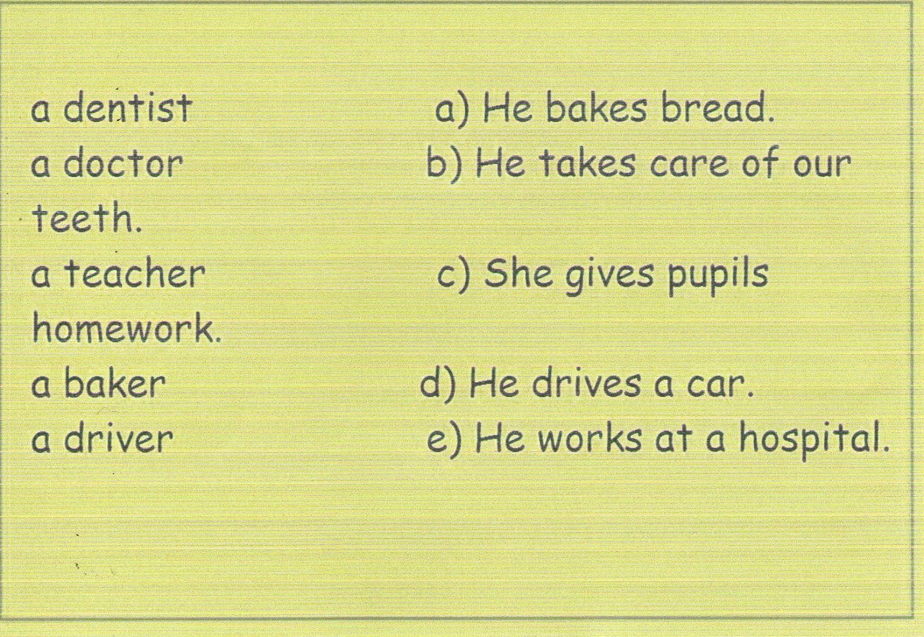
Activity 5. Read the sentences and correct them. Say them in the Past Simple.
