Административная контрольная работа по учебному предмету «Иностранный язык» 3 класс
Name:

My friend Peter is not tall. He is brave and strong. He is not lazy. His nose is short. His eyes are blue. He can run fast. He can play chess. He likes chocolate. He does not like fish. We go to school together.
1Прослушай текст и выбери правильный вариант ответа:
1) He is weak/strong.
2) He is lazy/not lazy.
3) His nose is short/big.
4) His eyes are green/blue.
5) He can/can’t play chess.
6) He doesn’t like milk/fish.
7) We go to school/sports club together.

2.Установи соответствие – соедини подчеркнутые буквы и соответствующие им звуком:
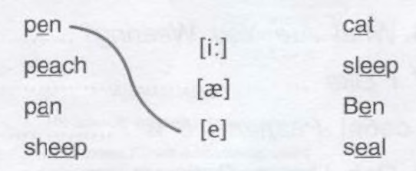

3.Прочитай предложения и напиши названия комнат.

1) An armchair, a table, a TV, a lamp are in the________________.
2 ) A table, chairs, shelves, food are in the ____________________.
3) The bath and shelves are in the _________________________.
4) A bed, a desk, toys, books, a computer are in the _________________.

4. Вставь в предложения is / are.
1) Mary ______ singing a song.
2) We _______ playing computer games.
3) Little Charlie ______ crawling.
4) My friends _______ climbing trees.
5) Val _______ dancing at the party.
6) The pupils _______ listening to the teacher.
7) Mum _______ cooking pizza

5. Выберите правильный краткий ответ и обведите его в кружок.
1. Are you a pupil? – Yes, I am./Yes, we is.
2. Is she ten years old? – Yes, she has./No, she isn’t.
3. Are they friends? – Yes, they do./Yes, they are.
4. Are you brother and sister? – Yes, we are./No, I’m not.
5. Is it my bag? – No, it isn’t./No, she isn’t.
6. Is he a good boy? – Yes, he am./No, he isn’t.

6. Выбери правильные формы глаголов в скобках и обведи их.
1) Birds (don/t / doesn’t) sing their songs in winter.
2) I (don’t / isn’t) live in Spain.
3) In winter we (play/ plays) hockey at the skating rink.
4) The crocodile (have / has) a long tail.
5) Andrew (isn’t / aren’t) from Canada.

Упражнение 2. Составьте предложения из слов.

1) five, there, in the park, children, are__________________
2) on the, there, a cat, is, sofa ________________________
3) little balls, there, three, are, in the box ___________
4) a big dog, in the room, there, is ___________________
5) a cake, there, in the picture, is ___________________

7. Прочитай предложения и вставь пропущенные слова из рамки.

happy thirsty hungry cold

Sam wants to have lunch. He is ____________________________
Mary wants to have a cup of tea. She is _____________________
Tim wants to put on a coat. He is ___________________________
Sarah has got a lot of presents. She is _______________________

8. Прочитай текст и утверждения после него. Если утверждение
верное, то поставь галочку (✓), если нет - крестик (✗).
Samson Leningradov is a giraffe. He is not very young, he is twenty years old. He is very tall and strong. He likes bananas very much. Samson can run very well. He lives in the zoo. He is a Moscow giraffe. He can see a lot of men, women and children by the cage. They like this giraffe and they like to some to the zoo. Samson doesn’t have a family now, but he has a friend, a grey cat. Its name is Masha. The giraffe and the cat play in the morning, in the afternoon and in the evening. They are happy.
1) Samson Leningradov is a giraffe. ✗
2) Samson lives in the wood. ✗
3) Samson has a family. ✗
4) Samson and Masha are not friends. ✗

